Typo that generates an error:
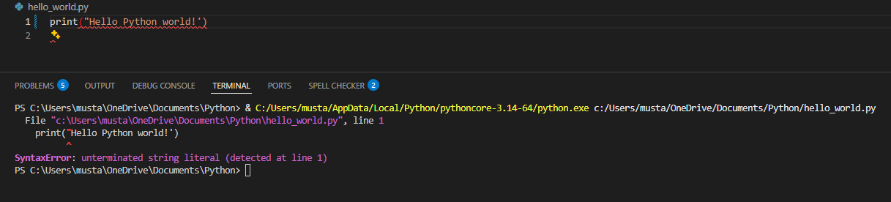
- The error message is saying the string that begins with the double quotation marks is never closed.

Typo that does not generate an error:
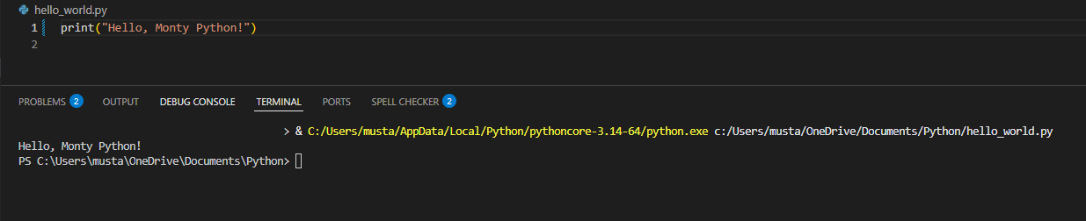
- The typo is within the message itself, but Python doesn’t check for that. The syntax is accurate and correct, so no error message is generated.

